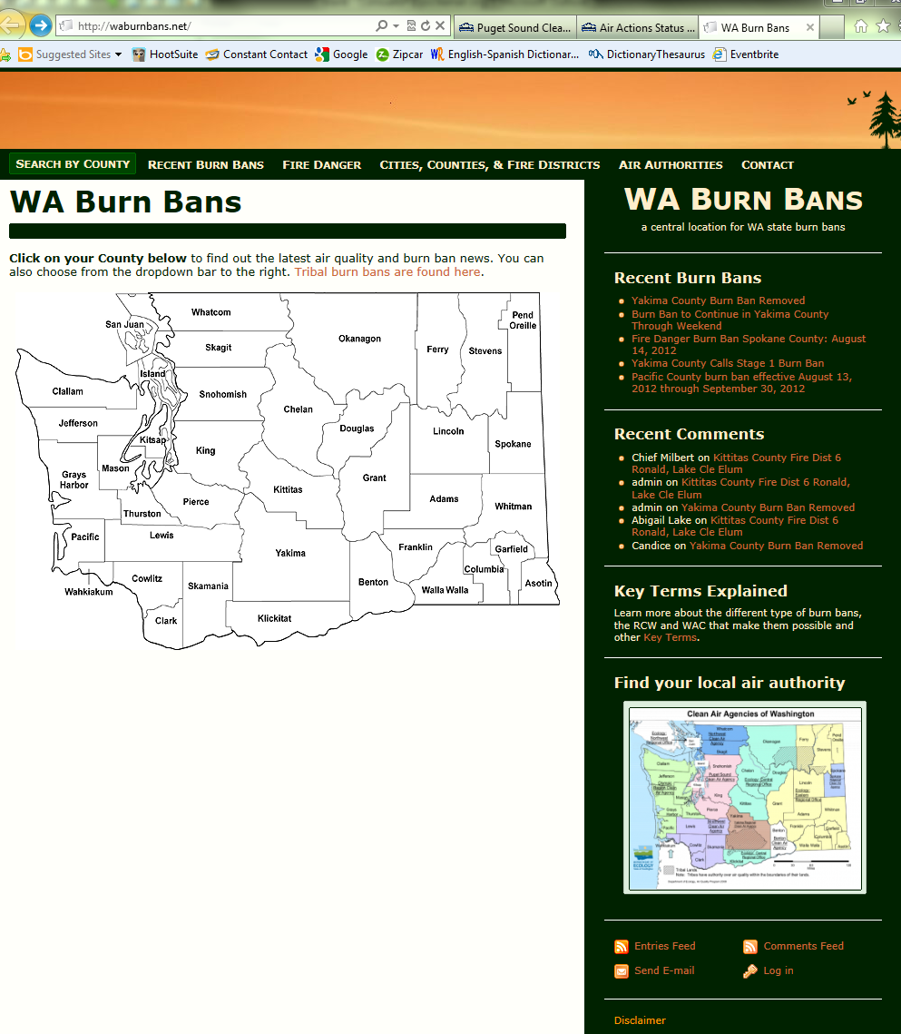
WaBurnBans.net is an online resource that consolidates all burn ban announcements – fire-safety and air-quality burn bans – for Washington State in one location. Olympic Region Clean Air Agency (ORCAA) hosts and maintains it as a free public service.

WaBurnBans Features:
- Search for bans by keyword, agency, or county using
a map or standard search bar.
- Registered users (e.g., Ecology, EPA, DNR, air agencies, fire districts, and others) have complete control over content using an editor similar to MS Word.
- Public can comment on burn ban posts.

To post your burn ban notices on WABurnBans, contact Mark Moore at mark.moore@orcaa.org, 360-586-1044.
How to Post to WABurnBans
Image #1
- Login. Located on the bottom-right of the web page. Use the login and password provided in your registration email. See image #1.

- Add a burn ban announcement by clicking on the “Add New” under “Posts.” See image #2.

Image #2

- Then, start writing!
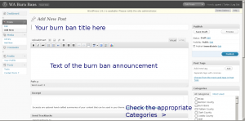
  - The title of your burn ban should contain the affected counties, type of ban (fire safety, etc…), and the start date of your ban. For example, Pacific County burn ban effective August 13, 2012 through September 30, 2012.
  - Remember to check the appropriate categories to ensure posts are defined by county, local air agency, and other. For example, for a burn ban in Spokane County, check categories “Burn Bans” and “Spokane County.”

Recent example:

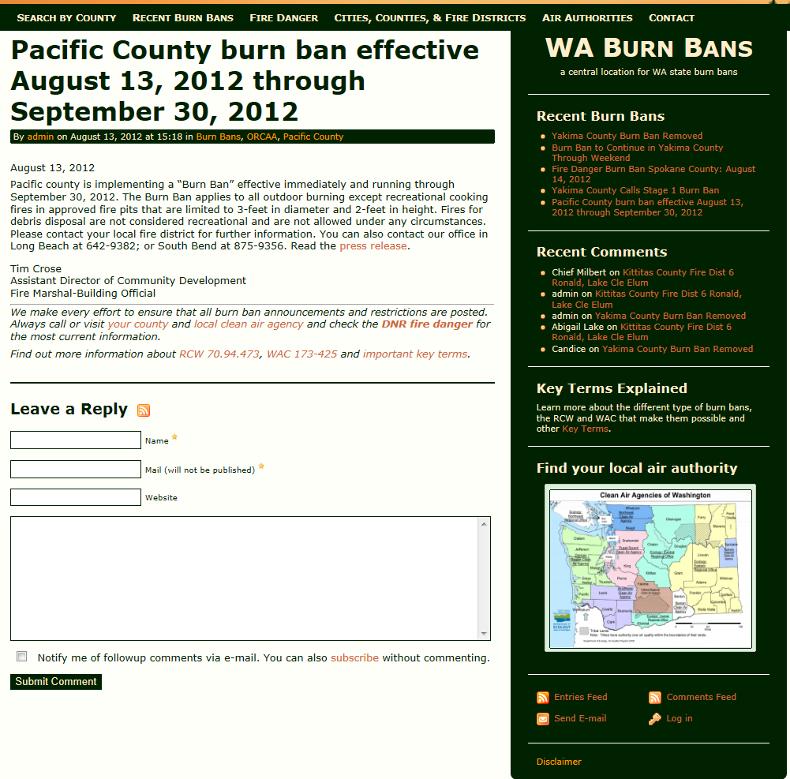

Image #3

